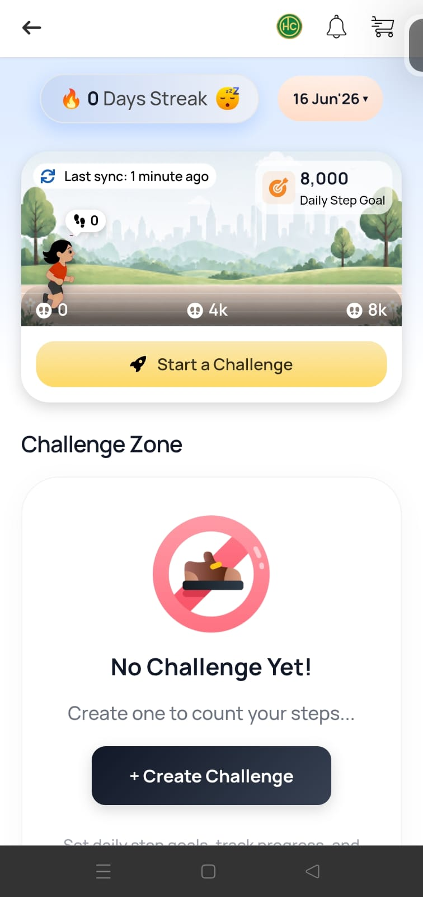
1. Review from a New User POV

Walking through the app as a first-time user:
- On opening the app, location/fitness permission is requested. After granting location permission, the app still shows a “Connect Now” prompt asking to link a fitness app — this two-step flow isn’t clearly explained, so a new user may think they’re done after the first permission grant when a second step (connecting a fitness tracker) is still required.
- Once a fitness app is connected and synced, the step goal display changes from a vague “10k Steps” (shown in a thought-bubble before connecting) to a concrete “8,000 Daily Step Goal” after syncing. This mismatch between the two numbers is confusing for a new user trying to understand their actual target.
- The “0 Days Streak” indicator appears from the very first launch with no explanation of what action starts the streak count.

Activity Tracker – UX Review & Recommendations
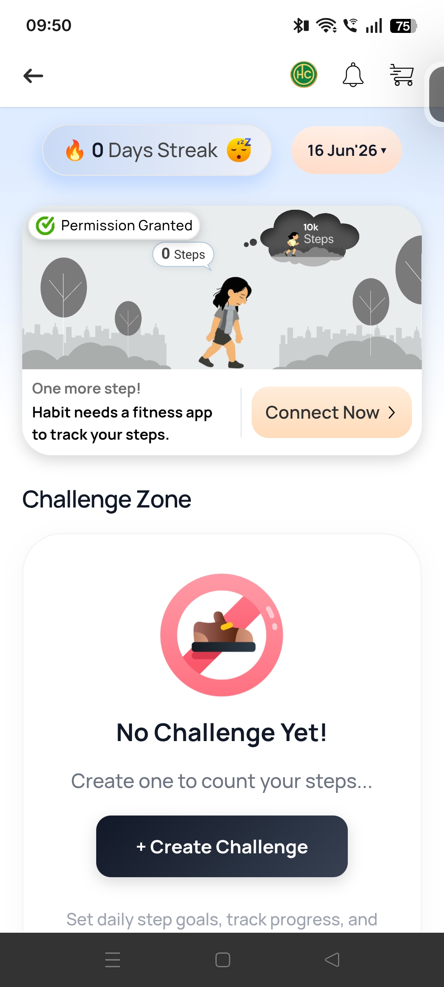

1. Permission vs. Connection Mismatch
Issue:
The screen shows “Permission Granted” while simultaneously asking users to “Connect Now” for a fitness app, creating confusion about whether setup is complete.
Recommendation:
Convert this into a guided setup flow:
Step 1: Location Permission ✓ → Step 2: Connect Fitness App.

2. Unclear Streak Logic
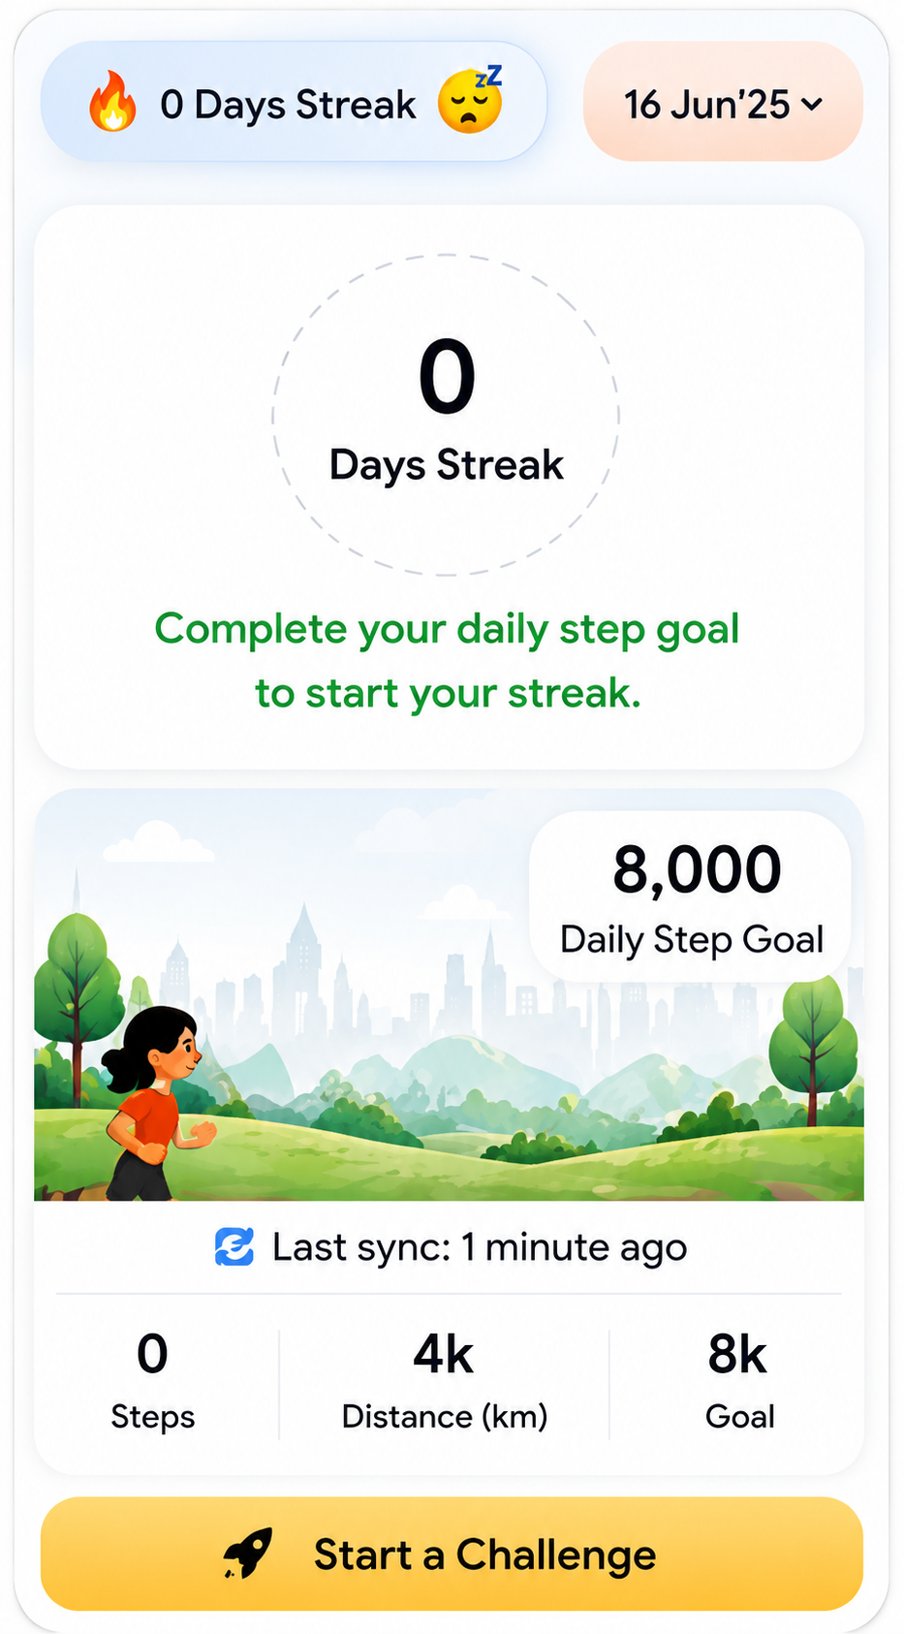
Issue:
Users see “0 Days Streak” but are not informed how a streak starts or how it is maintained.
Recommendation:
Add supporting text such as: “Complete your daily step goal to start your streak.”

3. Step Goal Inconsistency
Issue:
The step goal changes from 10,000 steps before sync to 8,000 steps after sync, making the experience appear inconsistent.
Recommendation:
Display the same step goal throughout the journey or clearly explain why the goal changes.

4. Duplicate Challenge CTAs

Issue:
Both “Start a Challenge” and “+ Create Challenge” appear to perform the same action, creating redundancy and weakening CTA hierarchy.
Recommendation:
Use a single primary CTA or clearly differentiate the purpose of each action.

5. Illustration Style Inconsistency
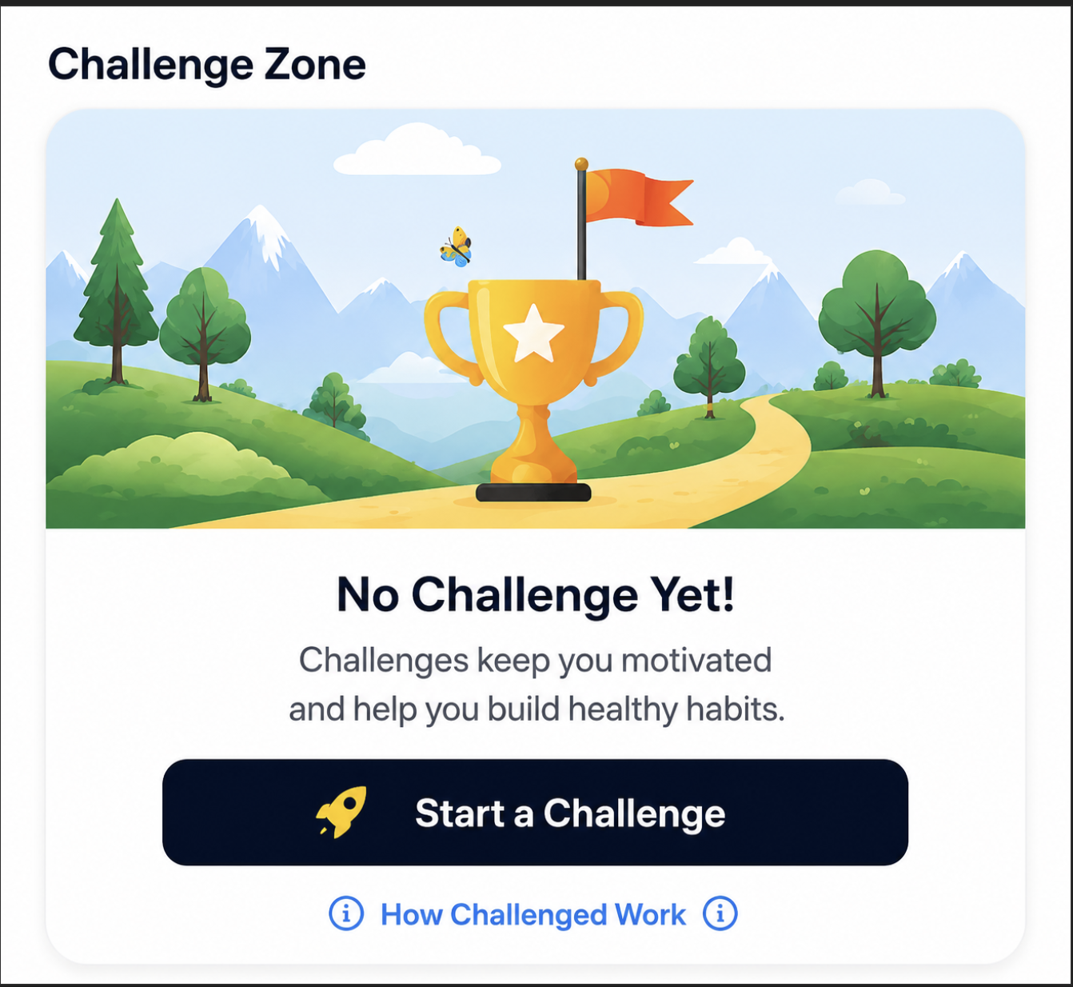
Issue:
The activity banner uses an illustrated scene while the Challenge Zone uses a flat icon, making the page feel visually disconnected.
Recommendation:
Adopt a consistent illustration style across all sections for a more cohesive experience.

6. Challenge Zone Icon Feels Restrictive
Issue:
The crossed-out shoe icon communicates restriction rather than motivation, which is not aligned with the purpose of challenges.
Recommendation:
Replace it with a more engaging visual such as a trophy, flag, footprints, or achievement badge, supported by a simple illustrated background.

